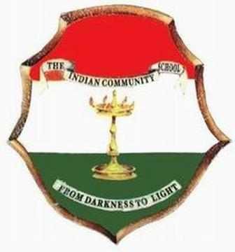 THE INDIAN COMMUNITY SCHOOL KUWAIT, AMMAN
Stud /Cir/ 2019- 2020/70

Dear Parent,

As you are aware about the decision of the Government of Kuwait to extend the school closure from 12th March to 26th March 2020, kindly note the following matters:
- Final examinations scheduled from March 15th 2020 onwards stand cancelled.
- Annual results for classes L.K.G to VIII will be declared on 26th March 2020 on the basis of annual average scored by the student in the examinations already conducted in 2019- 2020. Results can be availed through ICSK Cloud only by those students who have cleared their fees.
- In view of being up-to- date & maintaining the continuity of topics by students as they pass to higher grades, the school has decided to conduct an online “TMA – Teacher Marked Assessment” for students of Classes IV –VIII. This is an assessment of 25 Multiple Choice Questions in Science and Mathematics for Classes IV & V and in Science, Mathematics and Social Science for Classes VI to VIII to be compulsorily taken by each student and submitted on or before 20th March, 2020 through ICSK Cloud. TMA details will be shared on 15th March 2020.
- Please note that TMA results have no bearing on Annual results, it is only being done for better usage of available time by students and to be clear with the concepts.
- Fee counter and Uniform store will be open on Sundays to Thursdays from 4.00p.m. to 6.30 p.m. from Sunday, 15th March 2020 onwards. Kindly make use of online payment preferably.

Let us take all measures to unitedly counter the present emergency situation effectively.

Thanking you for your kind cooperation,

Rajesh Nair. C
Principal 10.03.2020

