 THE INDIAN COMMUNITY SCHOOL KUWAIT, AMMAN
Stud /Cir/ 2020- 2021/14
Dear Parent,
This is to inform you that the school has decided to begin Virtual Classes for students of Classes III, IV, and V by using the “Zoom Cloud Meeting” applications, the license of which was purchased by the school for the sole purpose of overcoming the emergency situation in Kuwait. It is a video conferencing software where the teacher is the host and around 100 students can become participants.

Kindly note the following matters for your immediate support and action.

- Virtual classes will commence on Tuesday, 14th April 2020.
- The classes will be on Sundays, Tuesdays and Thursdays from 8.00 a.m. to 11.15 a.m. (4 sessions of 40 minutes each)
- Class timetable is available in the ICSK Cloud web portal only. The timings mentioned in the timetable should be ignored.

- The software can be used by the student through either of the following medium (Requirement specified below)
- SMARTPHONE – Requirements
- 4G Internet connection or Wi-Fi with good broadband speed
- Headphones
- Download “Zoom Cloud Meeting” app from Google Play store (Android OS) or App store (iOS)
- LAPTOP /TABLET – Requirements
- 4G Internet connection or Wi-Fi with good broadband speed
- Headphones
- Download software from the link https://zoom.us/download#client_4meeting
or go to https://zoom.us/download meeting clients
- A mock session is arranged on Saturday, 11th April 2020 from 3.00 pm to 5.00 pm where your ward will be able to interact with subject teachers of the class.
VIRTUAL CLASS TIME TABLE FOR MOCK SESSION
TIME | CLASS III | CLASS IV | CLASS V
3.00 to 3.30pm | HINDI | MATH | ENG
3.30 to 4.00pm | EVS | HINDI | MATH
4.00 to 4.30pm | ENG | EVS | HINDI
4.30 to 5.00pm | MATH | ENG | EVS

- Attendance is compulsory for all students. The subject teacher who is taking the virtual class will be marking the attendance of the students at the beginning of the session.
- Class teacher will create a Zoom ID and share it in the respective Class ‎WhatsApp group 15 minutes before the session.
- Login to Zoom Cloud meeting 5 minutes before the class start with Class section, roll number and name. ‎ For e.g. IA32Reena, IIB30Manoj. ‎
- Sharing of the meeting details to outsiders is not entertained.
- The profile picture of the student should be kept blank.
- Microphone should be kept on mute and unmute only when required.
- Turn off the video throughout the session and turn it on only when teacher asks.
- Parents to ensure that there will be no external interference from the student’s side during the session.

Essential Steps for Your Ward’s Daily Customary

1st Step: Check the notes and links sent by the subject teachers in ICSK Cloud.

2nd Step: Check Timetable and attend your class regularly.

3rd Step: Write your assignments in your subject note book. Send the image (scanned /Photo)
to your subject teacher’s email id for correction and feedback.

4th Step: Prepare for bi-weekly or monthly online test as per the test schedule put up by the
school.

Steps to join the Virtual classes

QUICK REFERENCE GUIDE – ZOOM CLOUD MEETING

METHOD 1- ZOOM MEETING
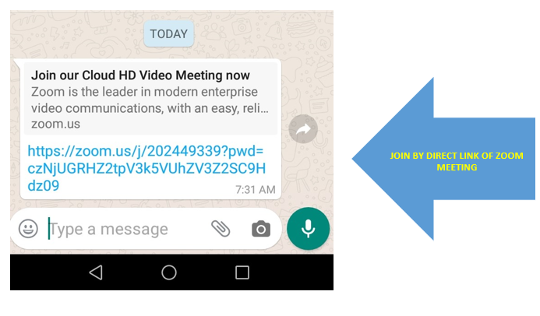
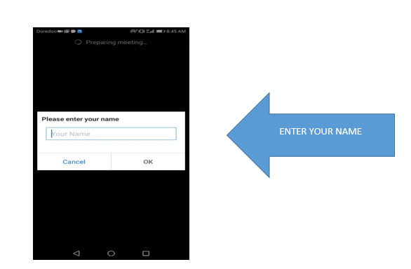

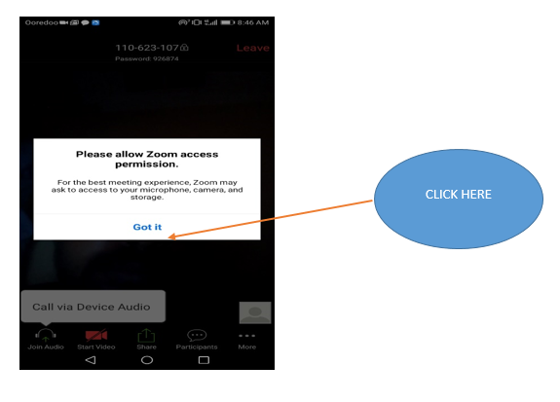
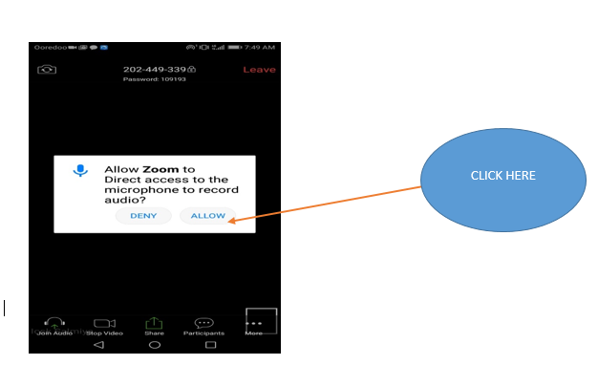
Step 1 Step 2

Step 3 Step 4

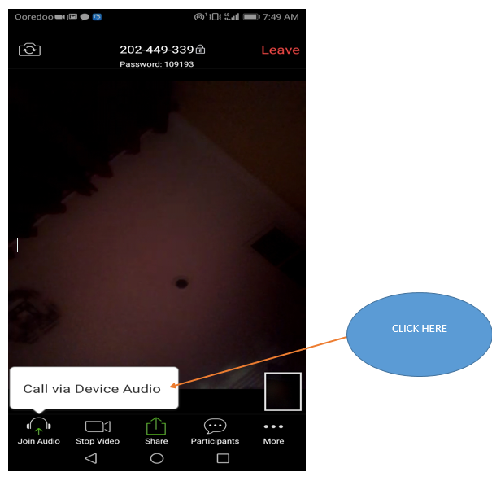

Step 5

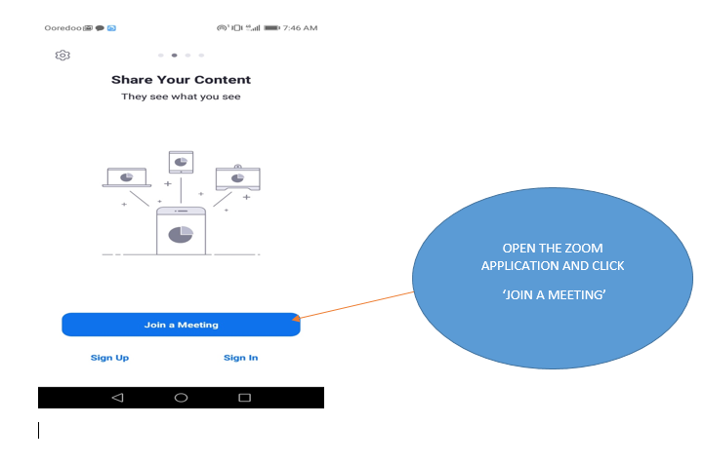
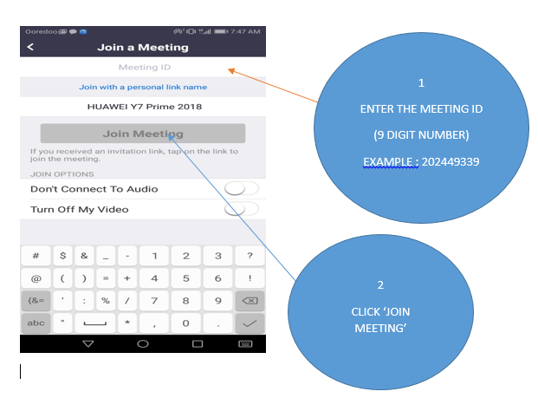
JOIN METHOD 2- ZOOM MEETING

Step 1 Step 2
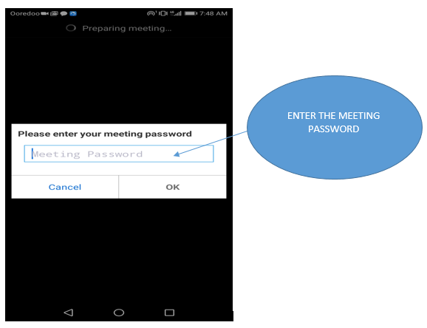
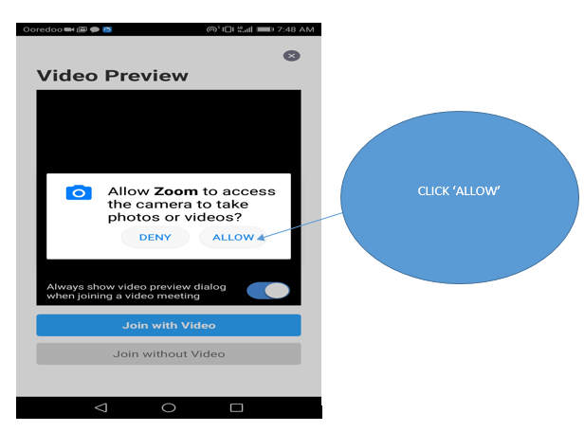

Step 3 Step 4
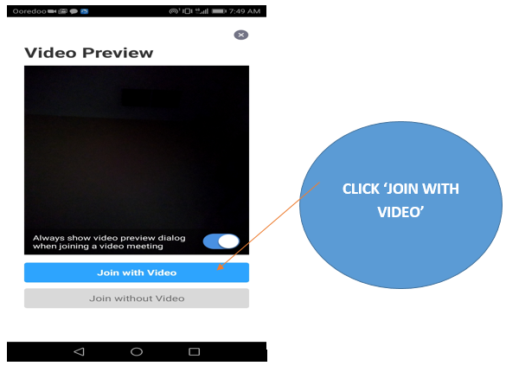
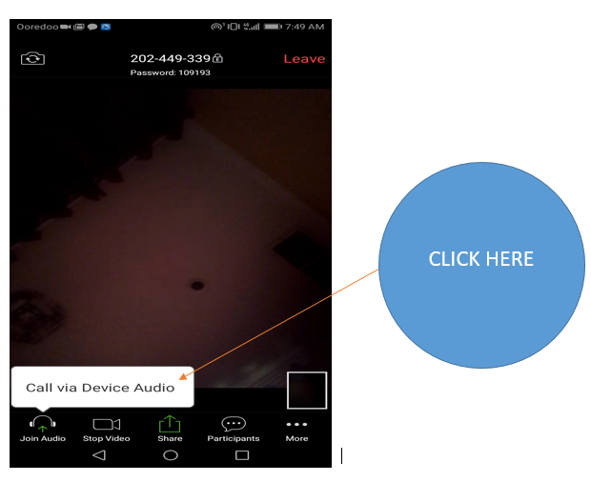

Step 5 Step 6

Looking for your support towards a successful academic year ahead.

Thanking you,

Rajesh Nair. C
Principal 10.04.2020

~~~~~~~~~~~~~~~~~~~~~~~~~~~~~~~~~~~~~~~~~~~~~~~~~~~~~~~~~~~~~~~~~~~~~~~~~~~~

