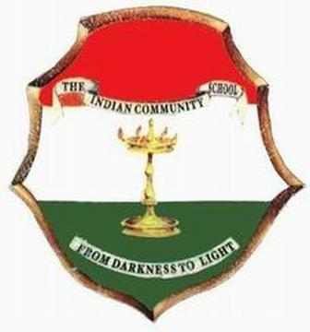 THE INDIAN COMMUNITY SCHOOL Kuwait, Amman

I TERM DATE SHEET - MAY 2019

Classes I to V

Date/Day | I | II | III | IV | V
14.05.2019  Tuesday | Computer Science(Oral) | Arabic | Arabic | Arabic | Arabic
15.05.2019  Wednesday | General Knowledge | Computer Science(Oral) | Moral Science / Islamic Studies | Moral Science / Islamic Studies | Computer Science  Practical
16.05.2019  Thursday | Moral  Science  (Written) /  Islamic  Studies (Oral ) | General Knowledge | Computer Science(Oral) | General Knowledge | General Knowledge
19.05.2019  Sunday | Math | Math | Math | Math | Math
20.05.2019  Monday | English | English | English | English | English
21.05.2019  Tuesday | EVS | EVS | EVS | EVS | EVS
22.05.2019  Wednesday | Hindi | Hindi | Hindi | Hindi | Hindi
23.05.2019  Thursday | Arabic (Oral) | Moral Science / Islamic Studies | General Knowledge | Computer Science  Practical | Moral Science / Islamic Studies
26.05.2019  Sunday | - | - | - | KSS | KSS

Rajesh Nair. C
Principal 25.04.2019

-------------------------------------------------------------------------------------------------------------------------------

